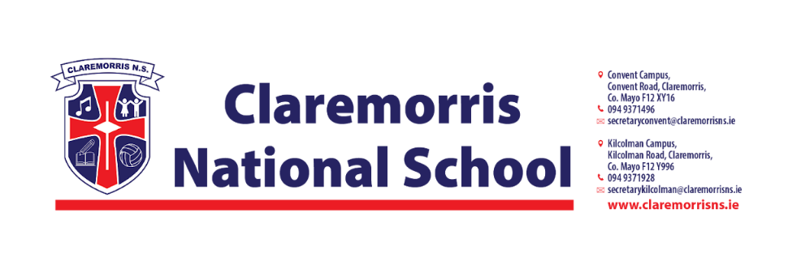
3rd Class Stationery List
2025/2026
All schoolbooks and workbooks will be funded by the Department of Education and bought by the school.
Children should bring the following items to school on 28th August:
1 x A4 Polly Pocket Display Book (60/80 Pages)
1 x A3 Plastic zipped Mesh Wallet ( to fit bigger books)
1 30cm ruler
3 Pencils and colours( twistables/coloured pencils)
2 x Red Pen (Bic)
1 x Black Sharpie Pens
1 x Small Scissors
1 x Pencil Sharpener and 1 x Eraser
2 x Pritt Stick
1 pack of 4 Whiteboard Markers
Earphones/Headphones if you have them from 2nd Class
2 x 88 page Sums Copy
3 x 88 page Writing Copies
3 x A4 Manuscript Copies with Durable Cover
1 pack of Playing Cards
 Tinwhistle ( Key of D)

In line with our Green Schools Policy, each child must have a reusable bottle and lunchbox. Tinfoil is not permitted for wrapping lunches.

