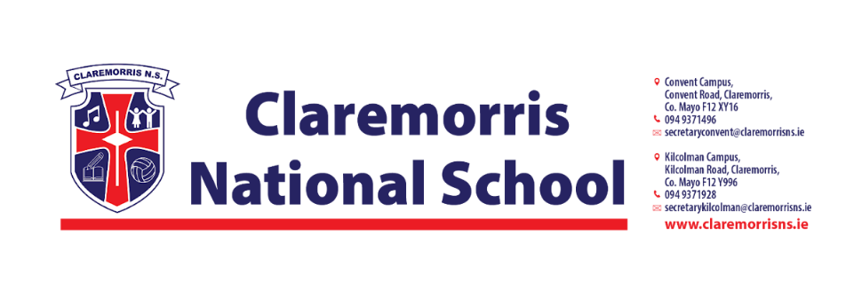
1st Class Stationery List
2025/26

All schoolbooks and workbooks will be funded by the Department of Education and bought by the school.

Children should bring the following items to school on 28th August.
4 x 15A project copies
2 x 11A regular copy, 120 pages
1 x A4 manuscript 120 page copy
Pack of 5 slide spine report file A4
Pack of button document folders A4
A3 mesh folder with zipper
Key of D Tin whistle (green lip piece)

3 large pritt stick glues
Twistables
Red biro
Pencils, rubber, topper, pencil case
1 Pack of Whiteboard markers

In line with our Green Schools Policy, each child must have a reusable bottle and lunchbox. Tinfoil is not permitted for wrapping lunches.

