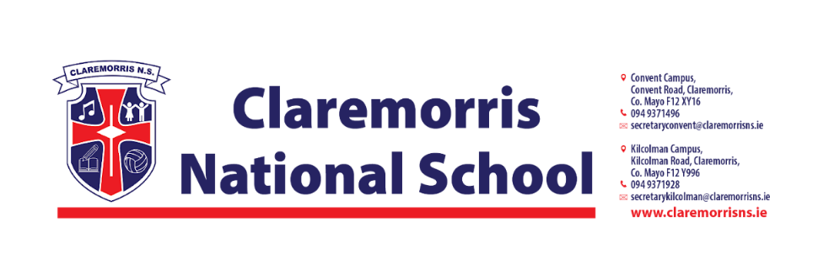
2nd Class Stationery List
2025/2026

All schoolbooks and workbooks will be funded by the Department of Education and bought by the school.

Children should bring the following items to school on 28th August:
1 x A3 Large Plastic Zipped Mesh Document Wallet – homework folder (with zip)
1 x Pencil Parer/Topper
1 x Eraser
1 x 30cm Ruler
2 x Pritt Stick
1 x Twistables
2 x HB Pencils
2 x Red Pen (Bic)
2 x Plastic A4 Folder
1 x 15A 12mm line space project copy
3 x 120 page writing copy
2 x A4 Softback Copy
1 x Tinwhistle (d)
2 x Whiteboard Markers
1 x Maths and Sum Copy

PLEASE LABEL ALL COPIES & FOLDERS

In line with our Green Schools Policy, each child must have a reusable bottle and lunchbox. Tinfoil is not permitted for wrapping lunches.

